**Validation Tests**

**Classic**

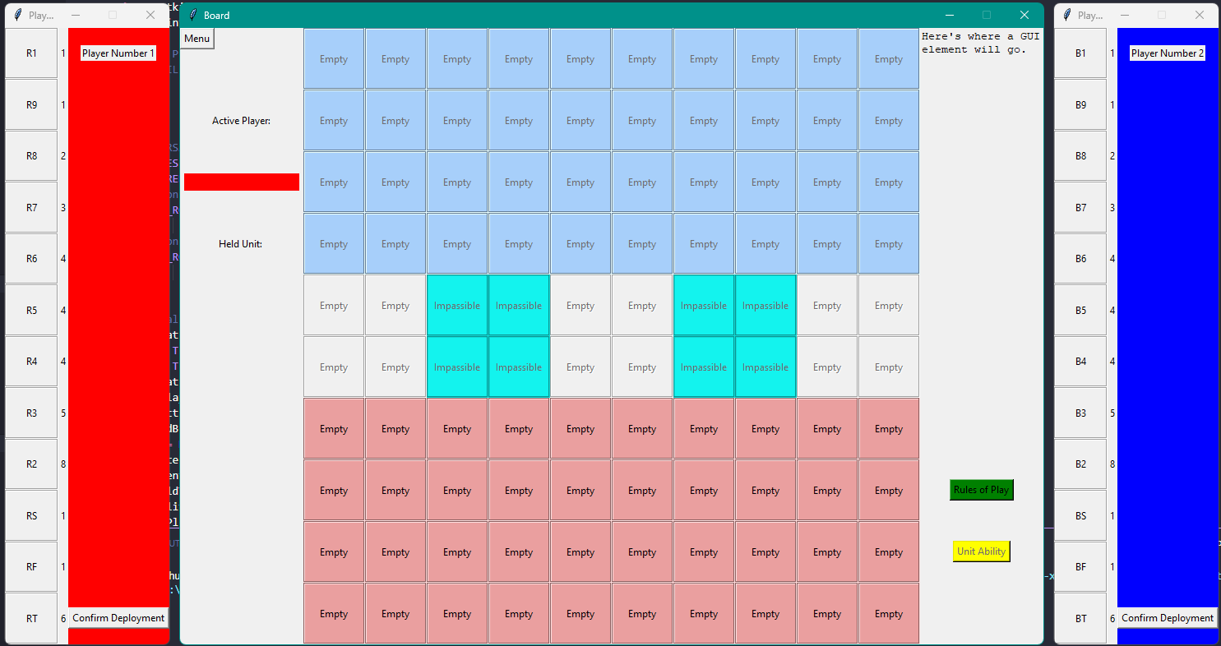

After starting the game, you are presented with the classic board.

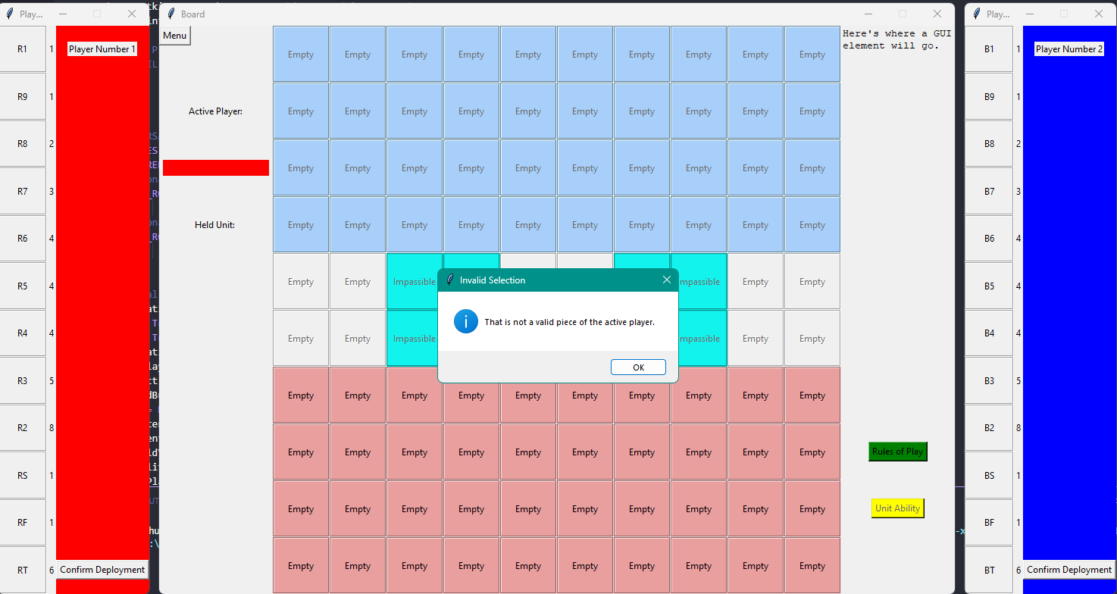

This is the error message you get when trying to select another player’s piece.

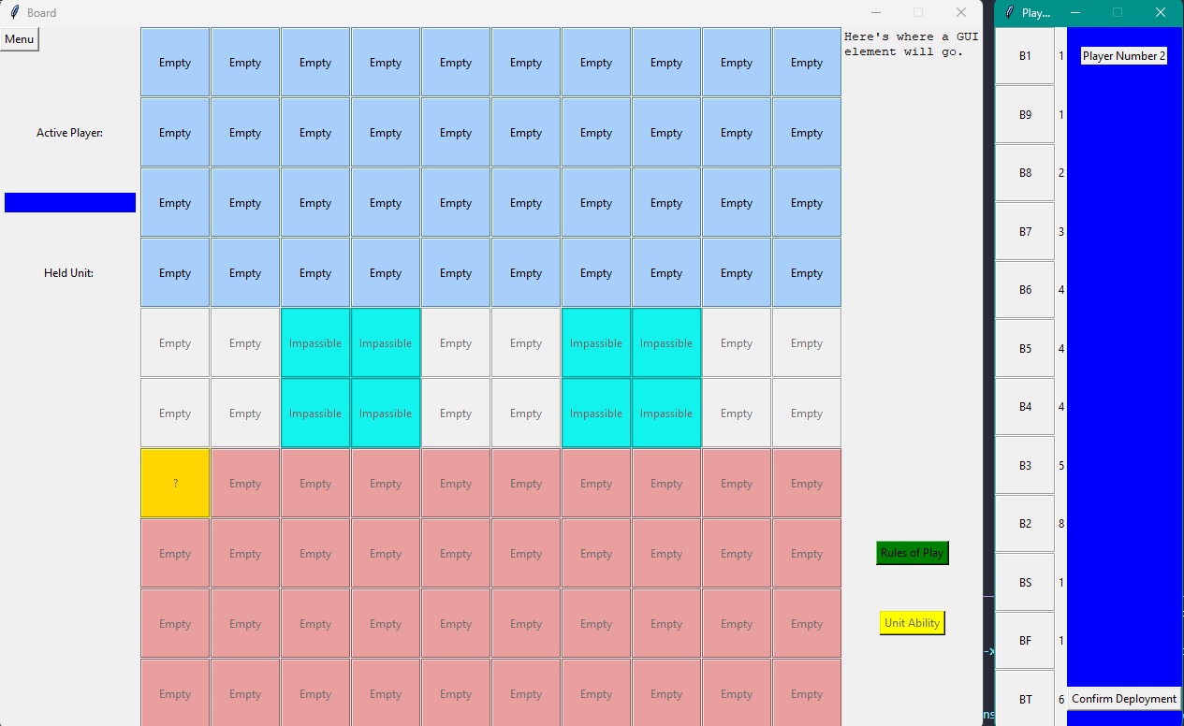

After placing a piece, that piece will be hidden while the other player places theirs.

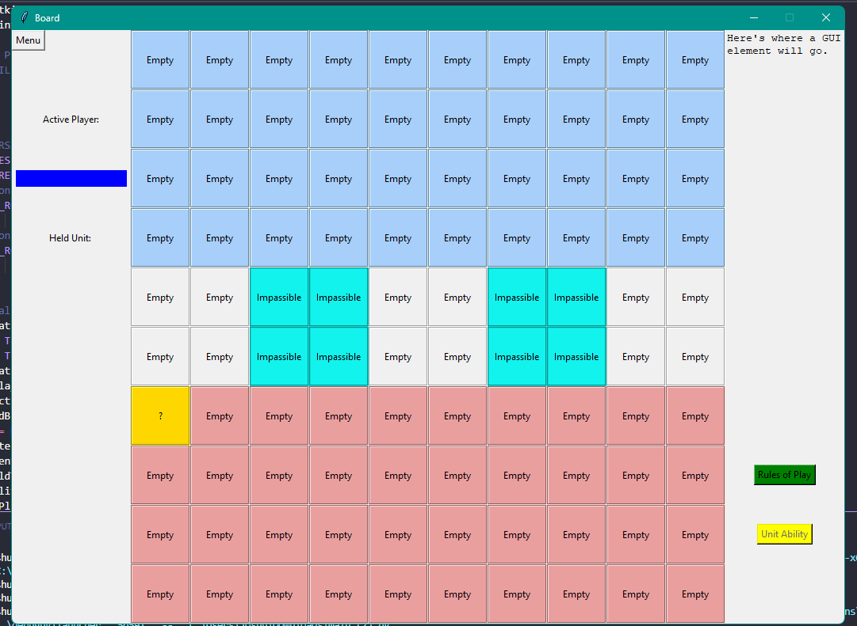

After confirming deployment, both player sheets will disappear and the players will begin to move pieces or attack.

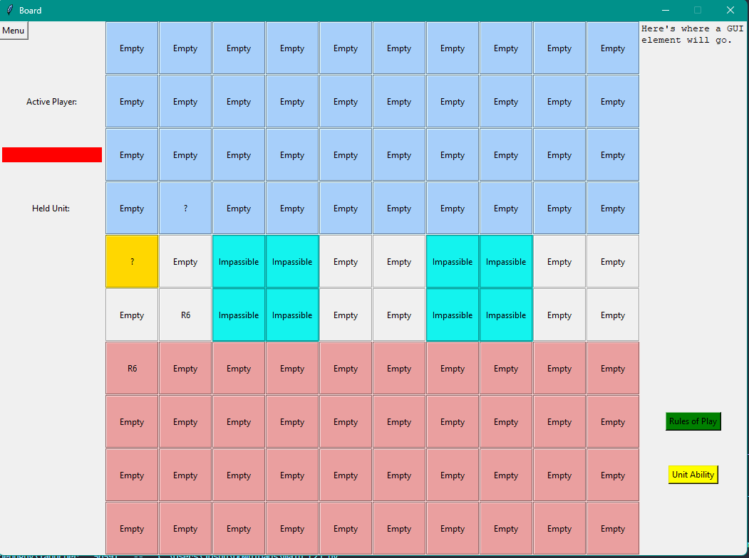

This is the board after making a legal move.

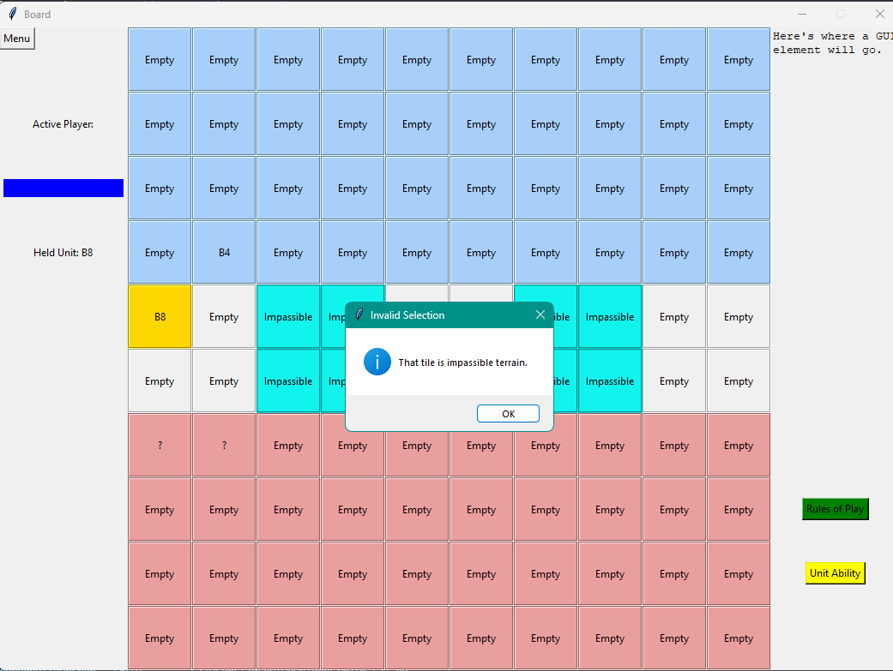

This is the error message you get when you try to move to an invalid space.

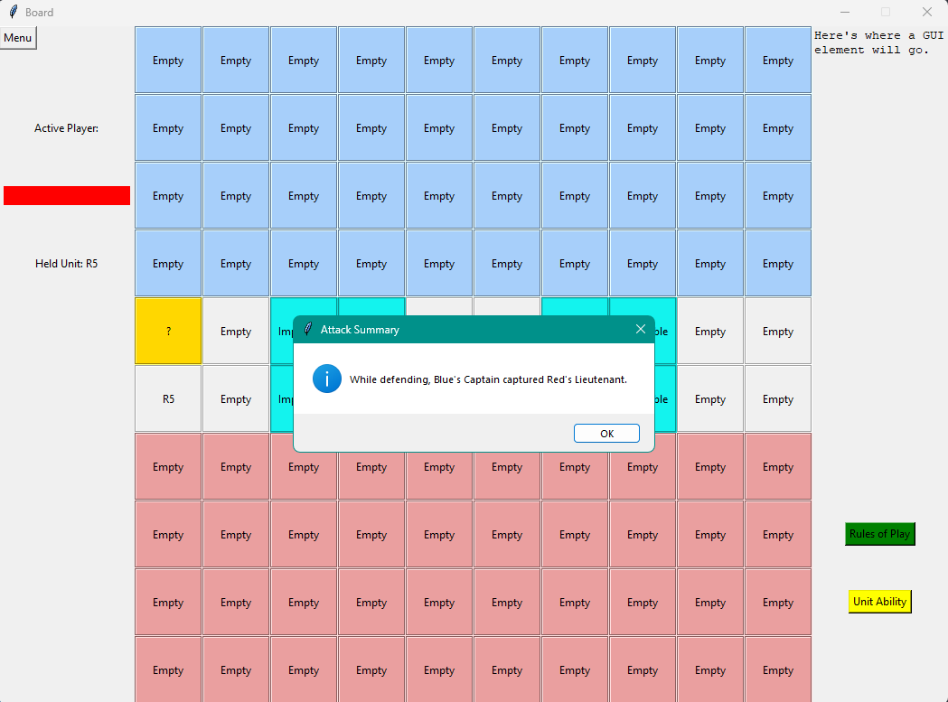

This is the message you get when attacking your opponent.

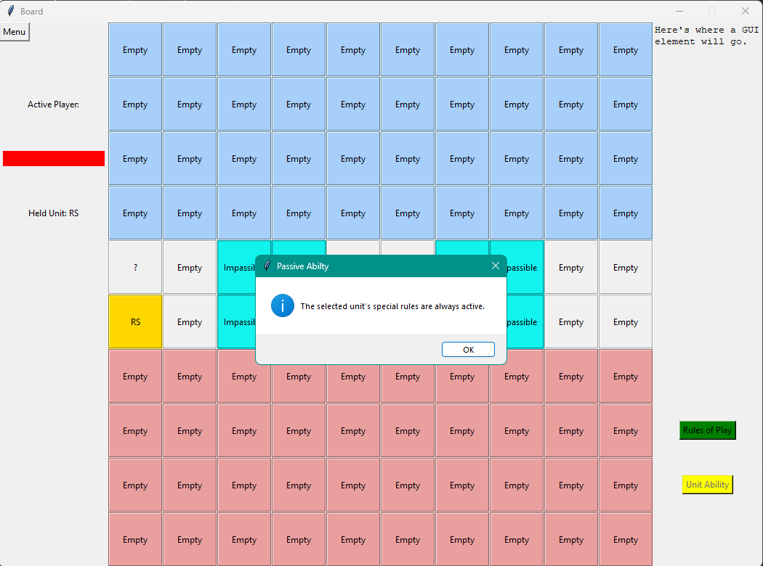

This is the pop up message you get when trying to use the scout ability.

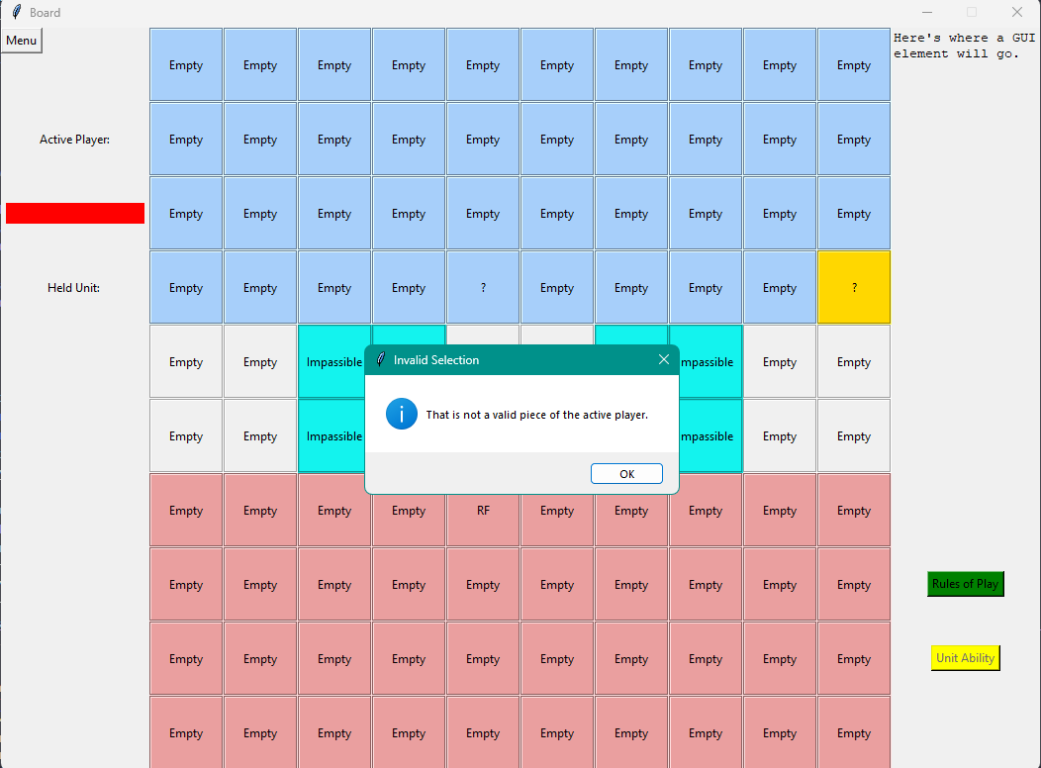

This is the error message you get when trying to move your flag or a trap.

**Fantasy**

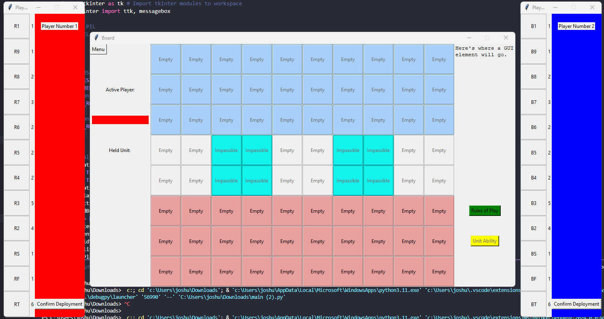

After selecting fantasy mode and clicking start game, this is the board you are presented with.

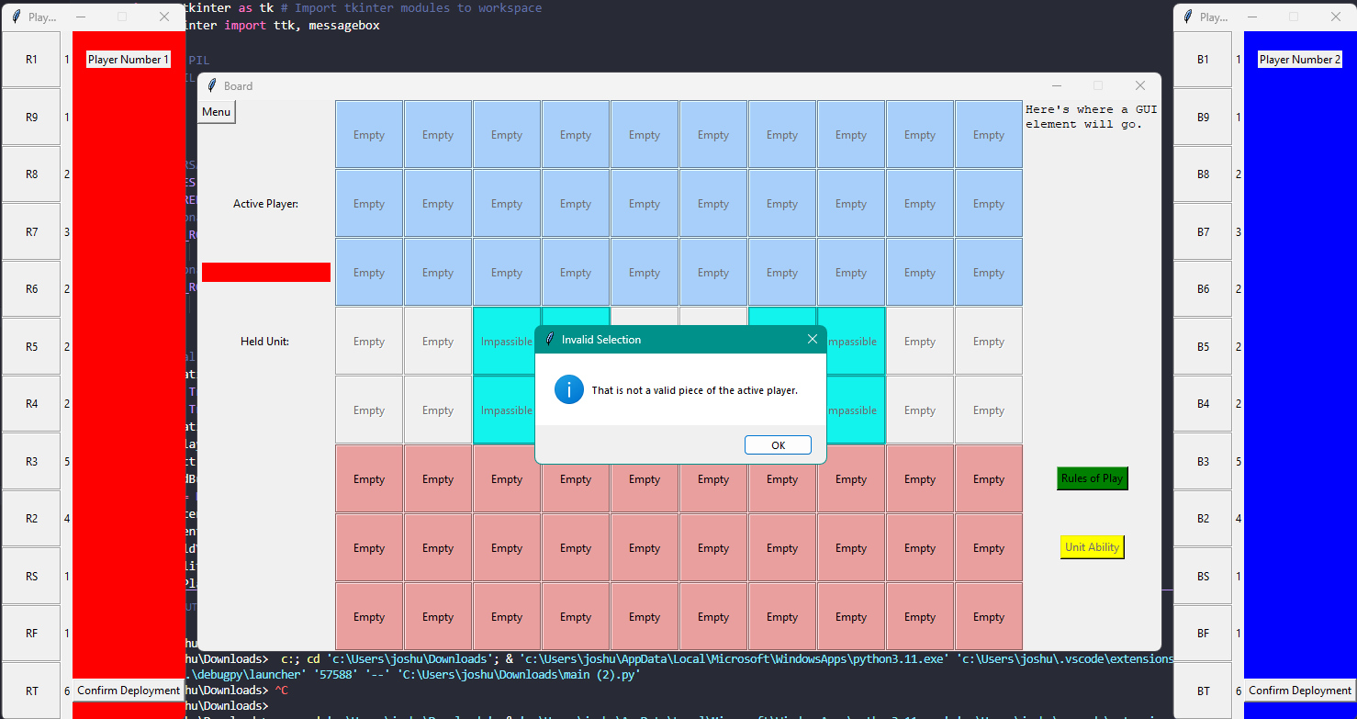

This is the error message you get when you try to select your opponent's player sheet.

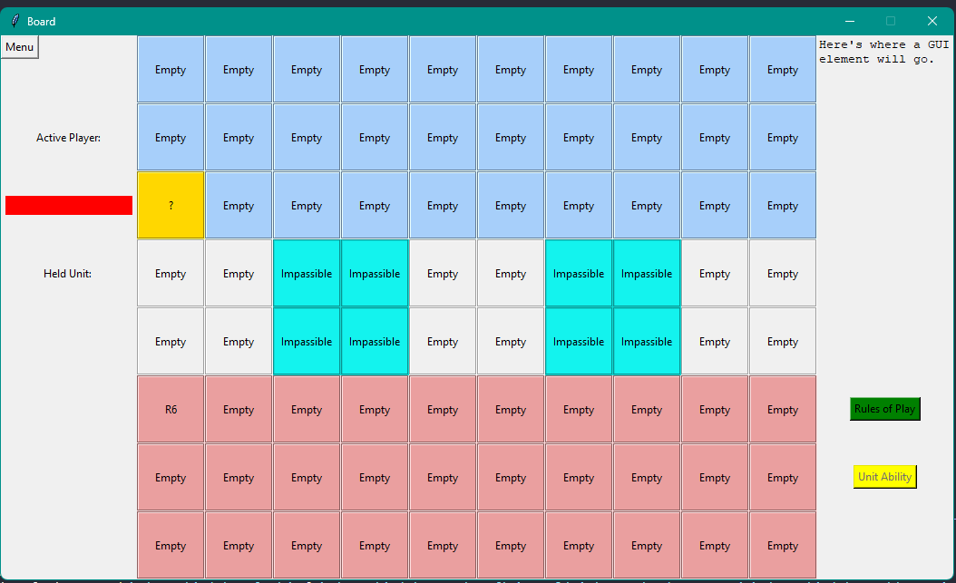

After confirming deployment, both player sheets will disappear and the players will begin to move pieces or attack.

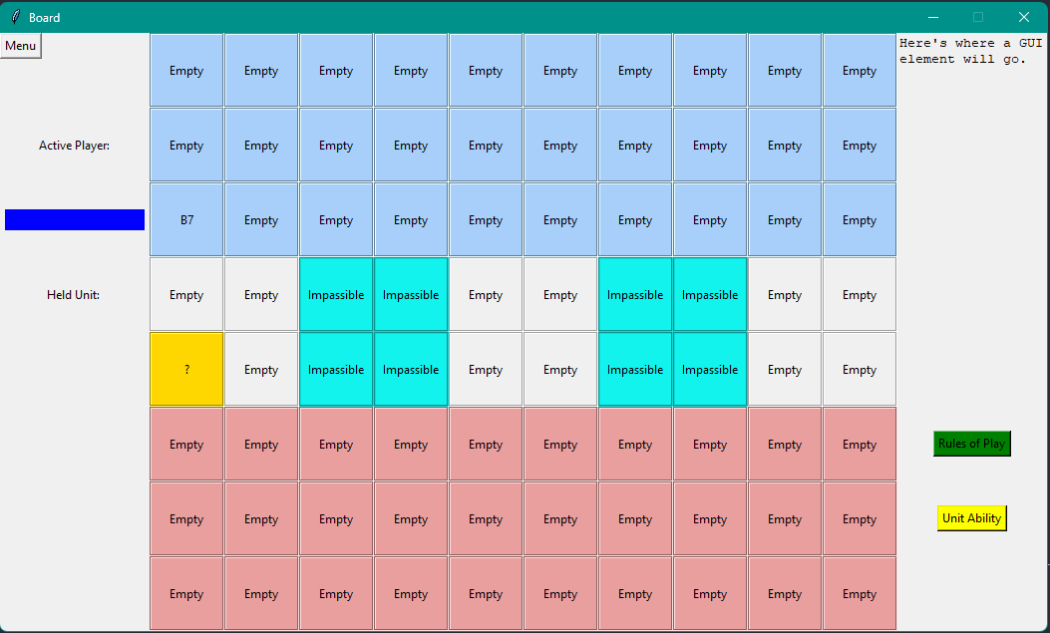

This is the board after making a legal move.

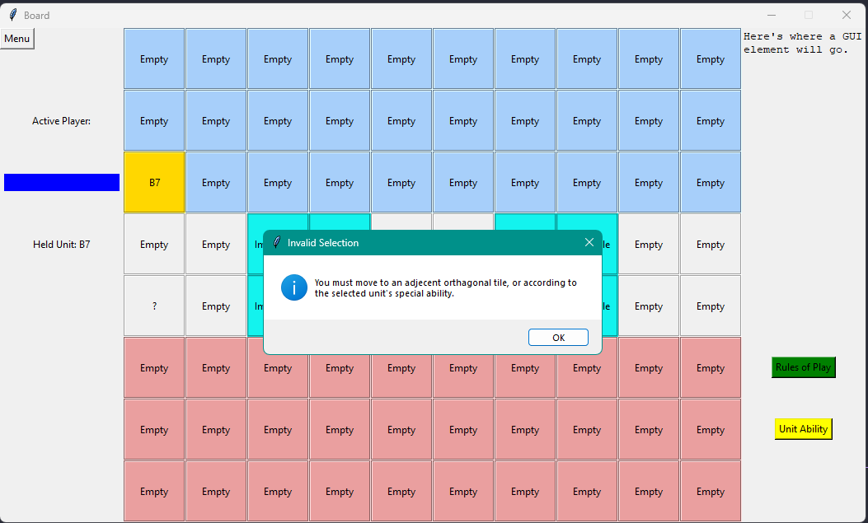

This is the error message you get when trying to make an illegal move.

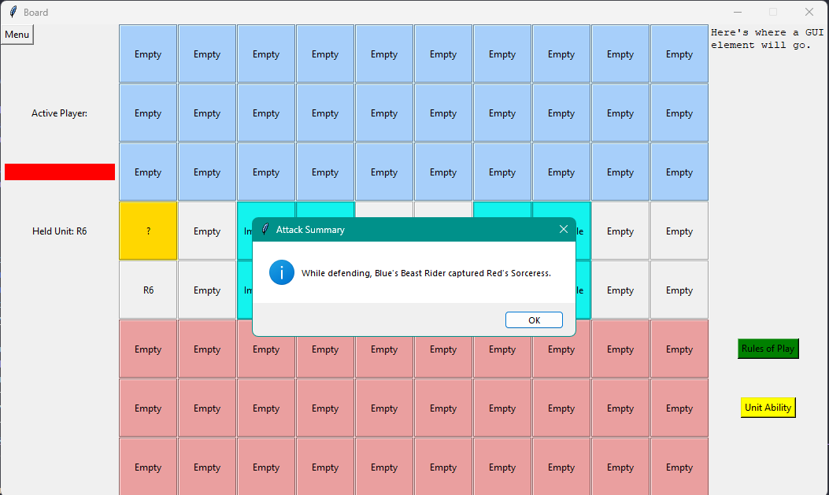

This is the message you get when attacking your opponent.

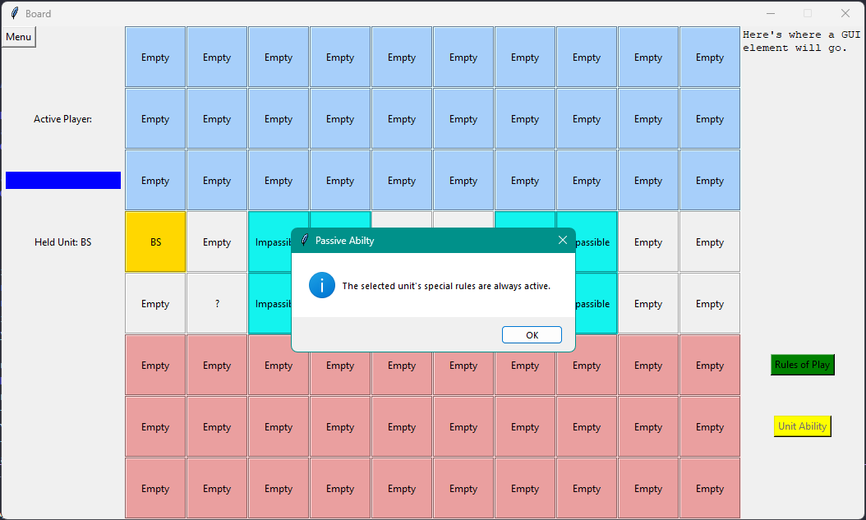

This is the pop up message you get when trying to use the scout ability.

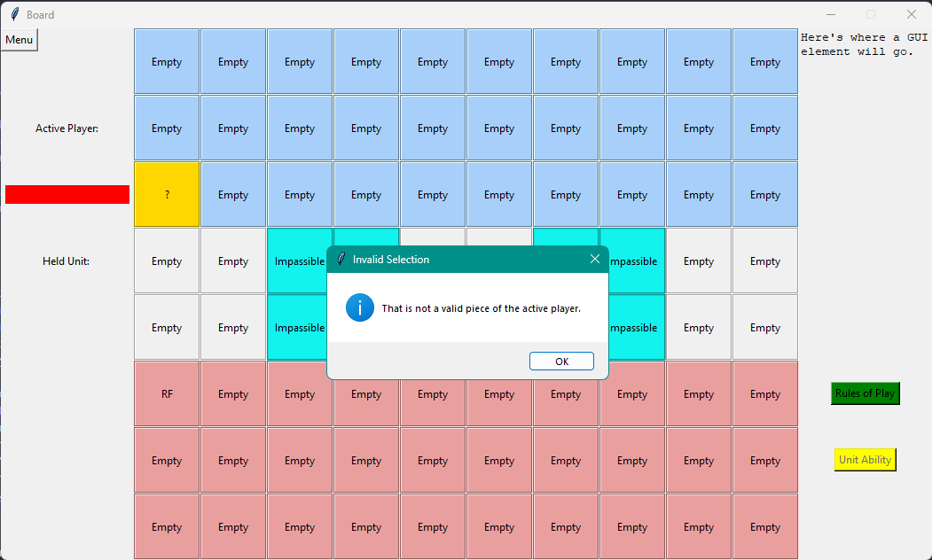

This is the error message you get when trying to move a bomb or a trap.